THE MARKS FAMILY

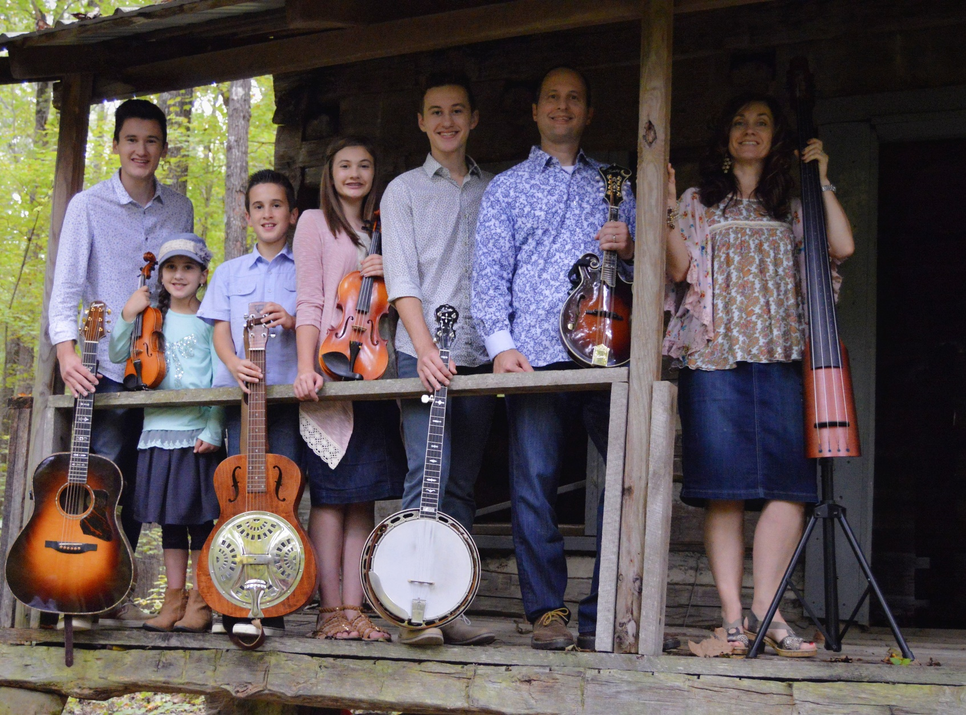
“Singing and Playing Music for the Glory of God”

SUNDAY JANUARY X, XXXX
XX:XX a.m.
XXXXXXX XXXXXX CHURCH
XXX XXXX
XXXXXXX, XX XXXXX
(XXX)XXX-XXXX
WWW.THEMARKSFAMILY7.COM

