COMING SOON!

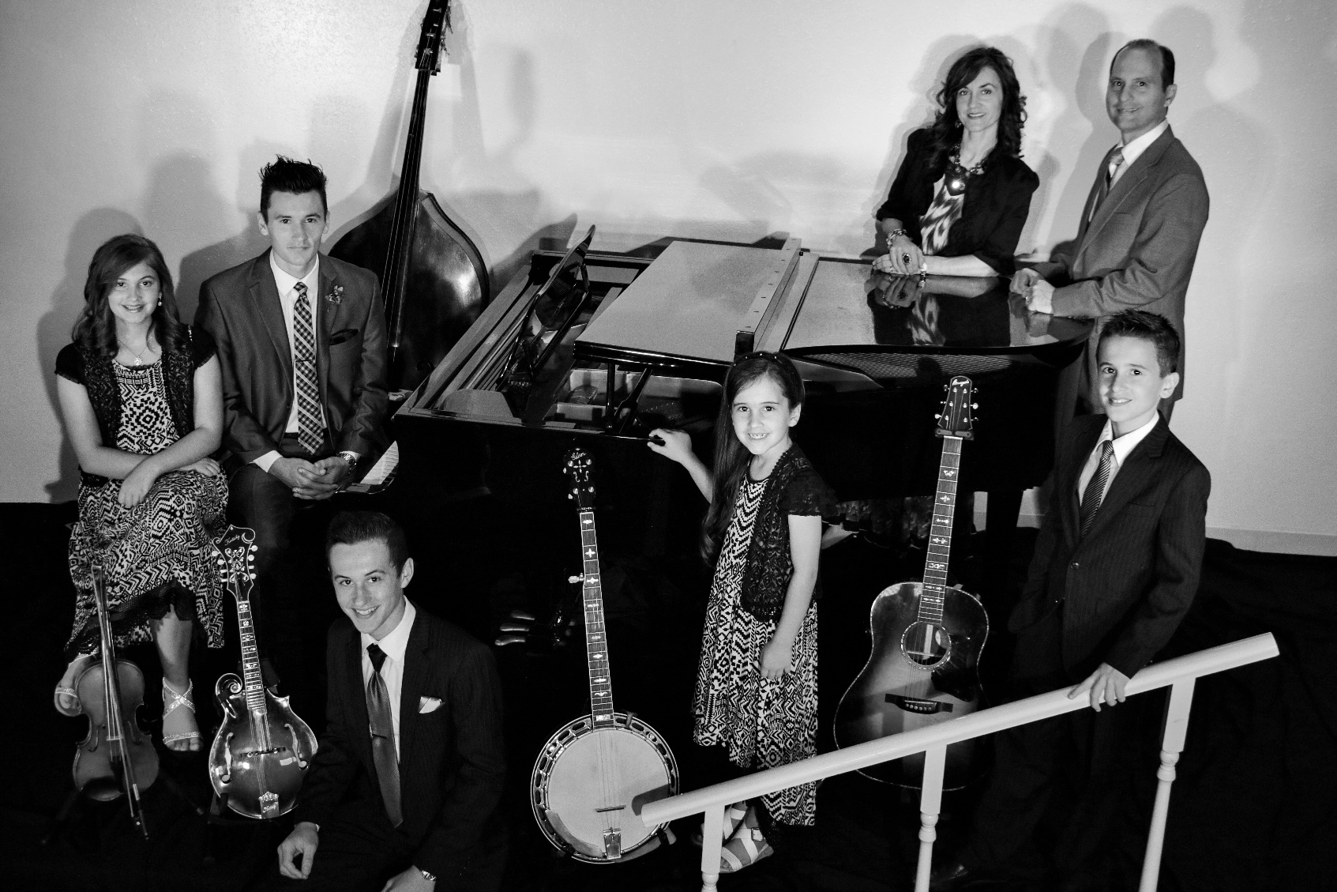
“Singing and Playing Music for the Glory of God”

THE MARKS FAMILY
MONDAY SEPTEMBER XX, 20XX
X:XX p.m.
XXXXXXXXXXXX
XXXXXX STREET
XXXXXXX, XX XXXXX
(XXX)XXX-XXXX
WWW.THEMARKSFAMILY7.COM

